4. import all these project

5. lets start from CoherenceIntroduction

6. go to run configuration and select oracle coherence

then create new

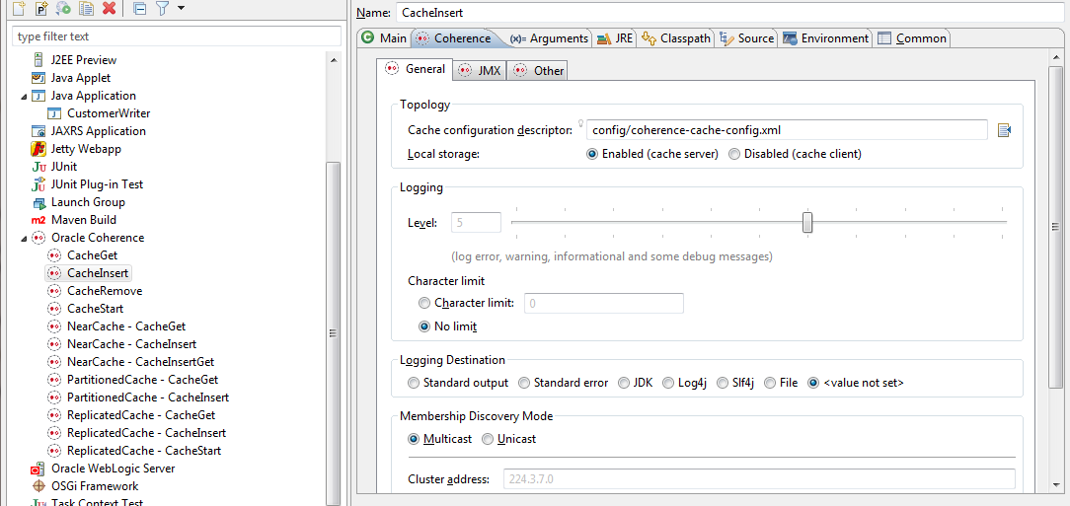

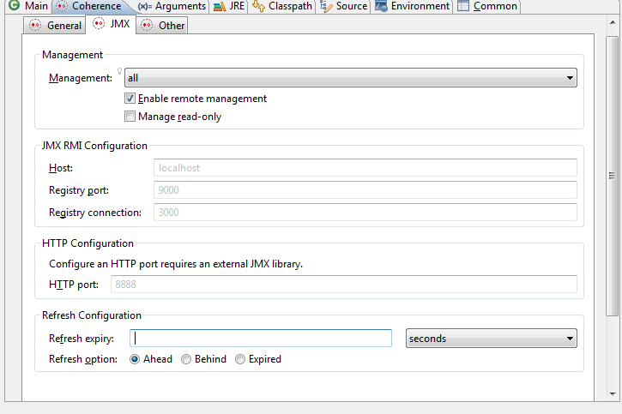

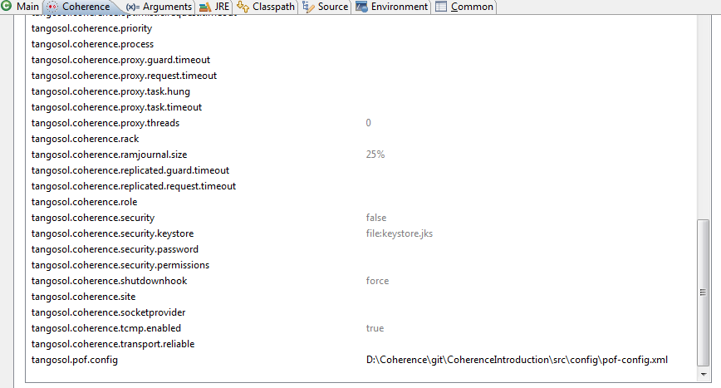

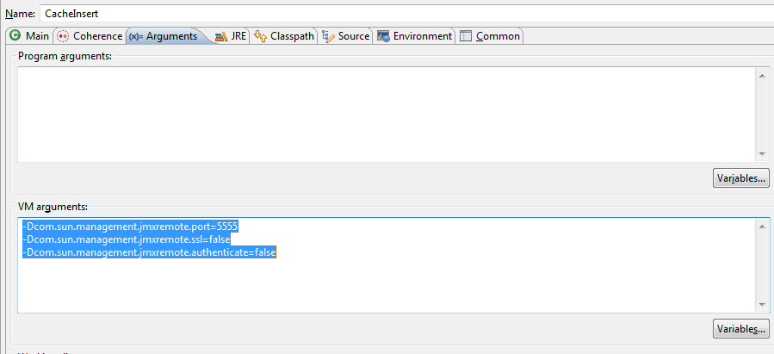

Set argument

-Dcom.sun.management.jmxremote.port=5555

-Dcom.sun.management.jmxremote.ssl=false

-Dcom.sun.management.jmxremote.authenticate=false